*Exercise : cell array*

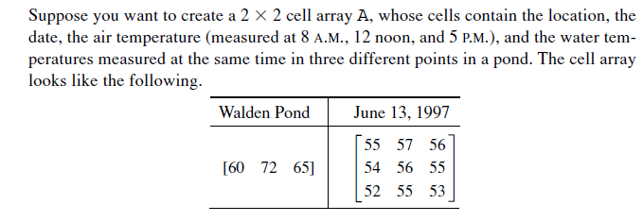

*Exercise: structure*

Ex 1.

% change the value of the structure using field name

clear student % clear student

student(1) = struct('name', 'Banny', 'scores', [85,80,92,78]);

student(2) = struct('name', 'Joey', 'scores', [80,85,90,88]);

student(3) = struct('name', 'Betty', 'scores', [88,82,90,80]);

1. get the values of the scores of every students
2. Calculate the average score of each student by

Average score=0.2\*score1+0.2\*score2+0.3\*score3+0.3\*score4

1. Add a field name ‘avg’ for the Average score of the student.

EX 2: Create a structure “student ” with the field name and the data as follows:

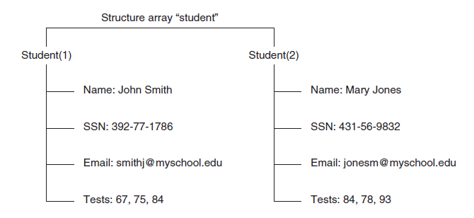

Ex3:

